**✨** HISTORY OF THE PLCs

Before 1968, factories-controlled machines using **relay-based systems**:

* Relays = little electromagnetic switches turning things on/off.
* To control one motor, you needed a power relay.
* To control *that relay*, you needed control relays.
* Add timers, counters… soon you had cabinets stuffed with hundreds of relays.  
  👉 Result: a hot mess. Hard to wire, hard to change, a pain to troubleshoot. 🤯



Enter 1968 (Hydra-Matic division of General Motors):

* Replace relay logic with a **solid-state controller**.
* Must support **ladder logic** programming (familiar to electricians).
* Must handle **harsh industrial environments** (dust, vibration, electrical noise).
* Must be **modular** (easy to expand and maintain).

Dick Morley’s team delivered:

**Modicon 084** – first commercial PLC (limited success due to memory & speed issues). Too slow to perform any function anywhere near the relay response time. In it were a processor board, memory, and a “logic solver” board, which parsed the algorithms associated with ladder logic.



**Modicon 184** – Robust, user‑focused design that turned PLCs into an industry standard. It ignited the market and began the changeover from relay-based control to solid-state units.



Key innovation:

Instead of physically rewiring circuits, engineers now just modify software logic.  
✅ Faster changeovers.  
✅ Reduced downtime.  
✅ Lower maintenance.  
✅ Space-saving, scalable control.

💥 Nick’s Fast Exam Lines:

*“Before PLCs, factories used complex relay-based systems that were expensive, huge, and hard to maintain.*

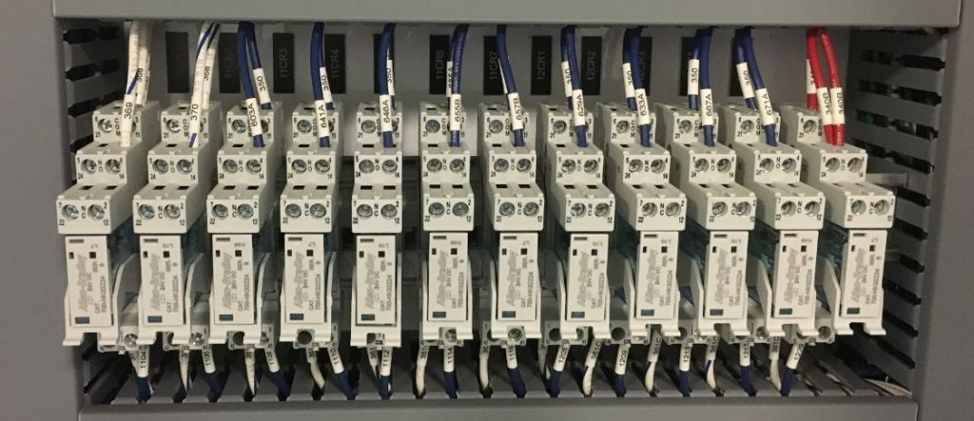

*In 1968, Dick Morley’s team created the first PLC (Modicon 084) to replace relays with a programmable, modular, solid-state controller. The breakthrough Modicon 184 later transformed automation worldwide.”*

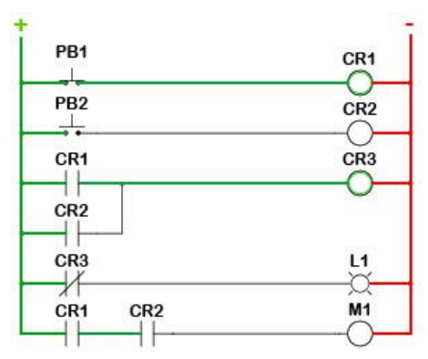

PLCS GROWING UP: FROM BASIC TO BOSS MODE! **📈**

The first PLCs were tiny, eager learners, fresh out of their "birth" phase.

They could handle the basics:

* **Inputs and outputs - turning things ON and OFF.**
* **Simple traditional relay‑style logic (coils and contacts).**
* **Basic Timers and counters.**

But just like a teenager hitting a growth spurt, PLCs quickly started adding some serious muscle and brainpower.

Leveling Up: New Powers for the PLC Brain **🧠✨**

The early PLCs were like a basic calculator, but they soon learned to do much more:

Math Whiz:

Since timers and counters already used "word size internal registers" (think of these as dedicated little memory slots for numbers), it was a natural next step for PLCs to start doing **simple math** – adding, subtracting, multiplying, dividing.

Soon after, they mastered **floating-point math**, allowing them to handle decimals and more complex calculations, which is super important for precise measurements.

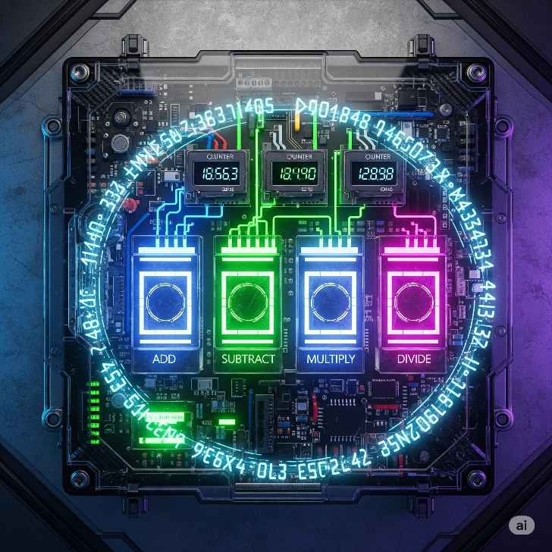

Enhanced Timing & Counting:

Beyond simple "start a timer for 10 seconds," PLCs gained **"one-shots"** (like a single-use trigger that fires once when activated) and more sophisticated timers and counters.

One-shot triggers and smart counters, letting them catch quick signal changes and control complex sequences more precisely.

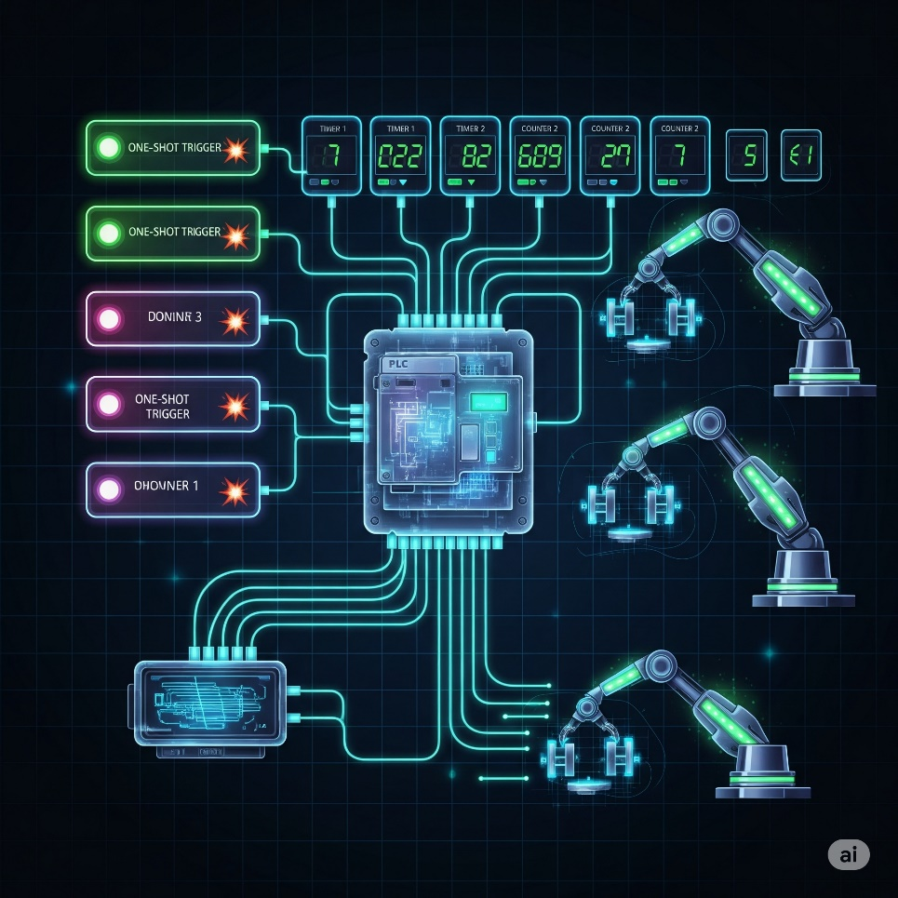

A bottling plant uses **smart counters** to track exactly how many bottles pass through each station, while **one-shot triggers** fire once to activate the capping machine only when a bottle is perfectly positioned.

Process Control Superpowers (PID):

PLCs gained built-in **PID controllers (Proportional-Integral-Derivative),** like having a lightning-fast autopilot that constantly fine-tunes systems to maintain perfect stability.

Imagine trying to keep the temperature of your shower *exactly* at 38°C. Without PID, you'd constantly be fiddling with the hot and cold taps, overshooting and undershooting, PID automatically keeps temperatures, pressures, and speeds exactly where they need to be, revolutionizing continuous processes in chemical plants, food production, and manufacturing.

A **pharmaceutical company** uses PID controllers to maintain precise pressure in tablet compression machines - as the powder density changes throughout production, the PID automatically adjusts hydraulic pressure to ensure every pill has exactly the same hardness and weight.

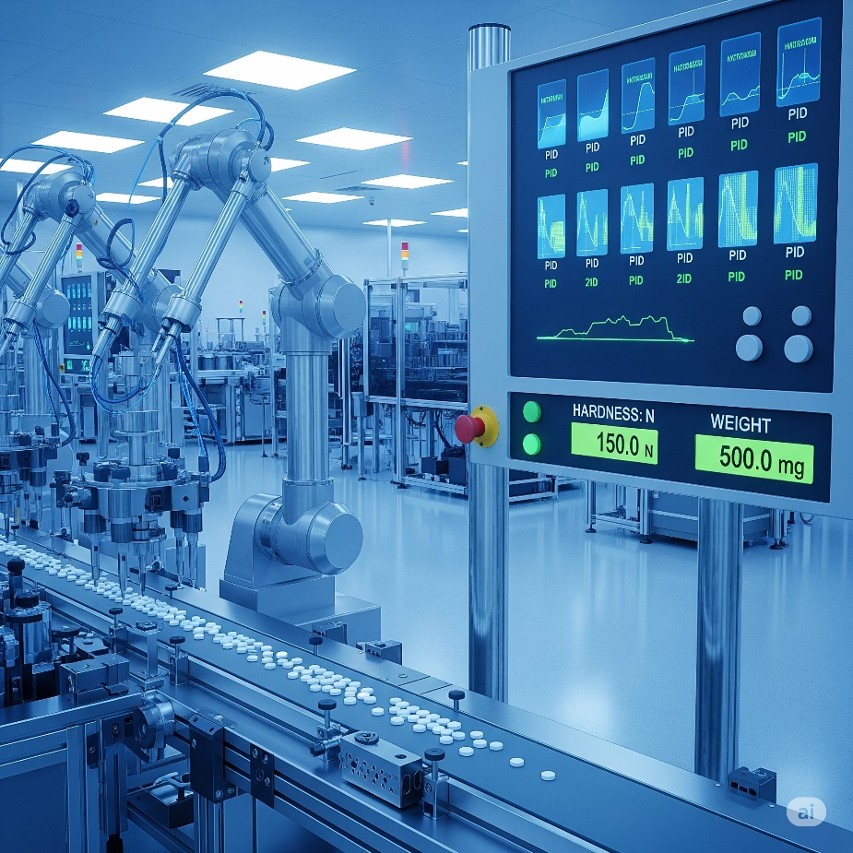

Drum Sequencers:

The OG rhythm masters of automation. These control machines that follow the same steps in order, every time. Like a car wash that automatically moves through: pre-rinse → soap → scrub → rinse → dry → wax.

Each step triggers specific actions and waits for completion before moving to the next, ensuring consistent results for any repetitive process.



Smarter Programming:

**Fill-in-the-blank data boxes:** Programming became more efficient. Instead of writing complex code for common functions, you could just fill in the blanks, like filling out a digital form.

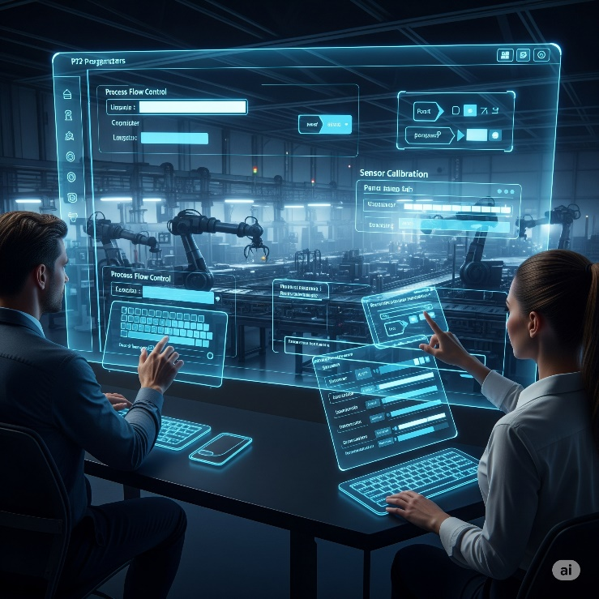

**Meaningful Tag Names:** This was a lifesaver! Instead of cryptic labels like "I:0/0" or "N7:0," engineers could use **descriptive "Tag Names"** like "Start_Button," "Conveyor_Motor_ON," or "Tank_Level_Sensor."



**Real-world analogy:** Imagine if all your contacts in your phone were just numbers instead of names. Tag Names are like giving your friends actual names so you know who you're talking to! This made programs way easier to understand, debug, and maintain, even for someone new to the project.



**Import/Export Tags:** The ability to easily move these Tag Names between different devices (like the PLC and an HMI) eliminated errors and saved tons of time from manually re-entering information. **Human Machine Interfaces** replace manually activated switches, dials, and other controls with graphical representations of the control process and digital controls to influence that process.



*We moved from hardwired panels to smart HMIs.* *Less physical clutter, more data visibility, fewer mistakes.*

TALKING THE TALK: PROGRAMMING & COMMUNICATION EVOLUTION **🗣️💻**

As PLCs got smarter, so did the tools used to program them and the ways they communicated with the outside world.

Programming Devices:

**The "Suitcase" Era:** Early programming devices were dedicated, clunky, and literally the size of suitcases! Not exactly portable.

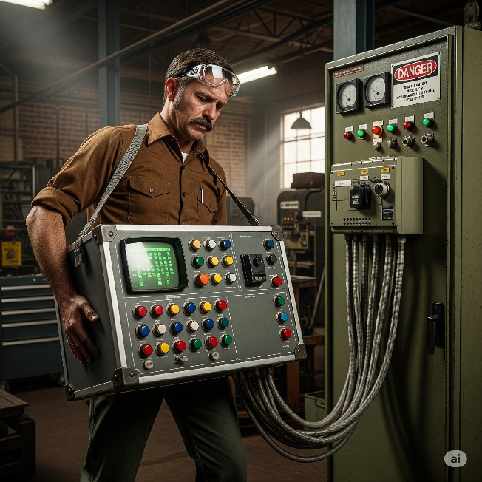

**Handhelds:** Then came smaller, handheld devices, offering a bit more freedom.

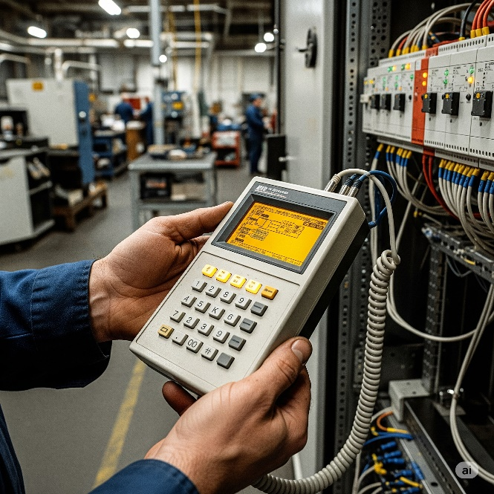

**PC Software Takes Over:** The real revolution happened when proprietary programming software moved to personal computers (PCs).

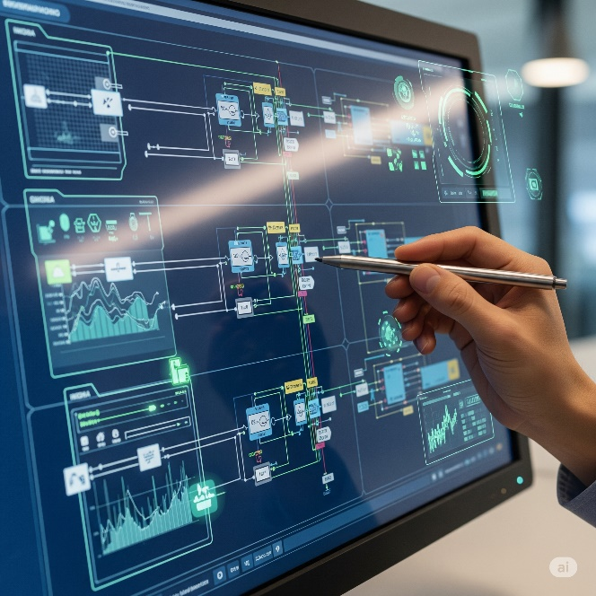

AutomationDirect's **DirectSOFT** was a pioneer as the first Windows-based PLC programming package. This was huge!



Having a PC meant:

* **Visual Programming:** You could see your ladder logic (or other programming languages) clearly on a screen.
* **Easier Testing & Troubleshooting:** PCs offered powerful tools for monitoring the PLC's status in real-time, simulating logic, and quickly pinpointing problems. It was like getting X-ray vision for your machine's brain.

Communication Protocols:

PLCs needed to talk to other devices, and this area saw rapid growth.

1. The Early Days (MODBUS & RS-232): Communication started with basic serial protocols like MODBUS over RS-232 (think of an old-school serial cable connecting two devices directly).

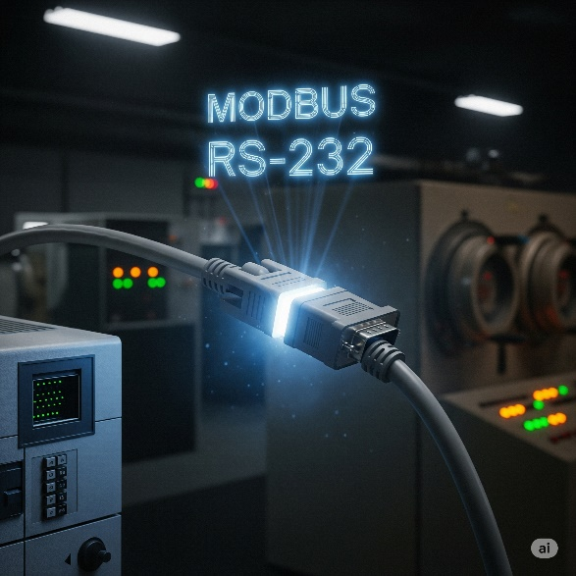

2. Expanding the Network (RS-485, DeviceNet, Profibus): As automation grew, so did the need for PLCs to talk to *many* devices over longer distances. This led to protocols like RS-485, DeviceNet, and Profibus. These new protocols were like setting up a small office network where multiple devices could chat.



**Industrial cables** branch out like highways, each carrying data through protocols like **RS-485, DeviceNet, and Profibus**.

**Sensors** act as the factory's eyes and ears, constantly monitoring temperature, pressure, and product presence. **Drives** function as muscles, controlling motor speed and direction. **Remote I/O modules** serve as nerve endings, extending the PLC's reach across the factory floor.

**Data pulses** flow along these lines like a digital heartbeat, making the invisible network work visible. The blue and orange lighting emphasizes how advanced industrial automation has become.

These **communication protocols** connect everything together, letting the PLC manage hundreds of devices across massive factory operations.

3. The Ethernet Era:Ethernet became the standard for industrial communication through protocols like EtherNet/IP. It's fast and lets PLCs connect with drives, robots, and touchscreen interfaces, creating smart factories where everything talks to each other.

PLCs evolved from simple relay replacements into powerful controllers that handle complex math, manage processes, and communicate with other machines - becoming the backbone of modern industry.

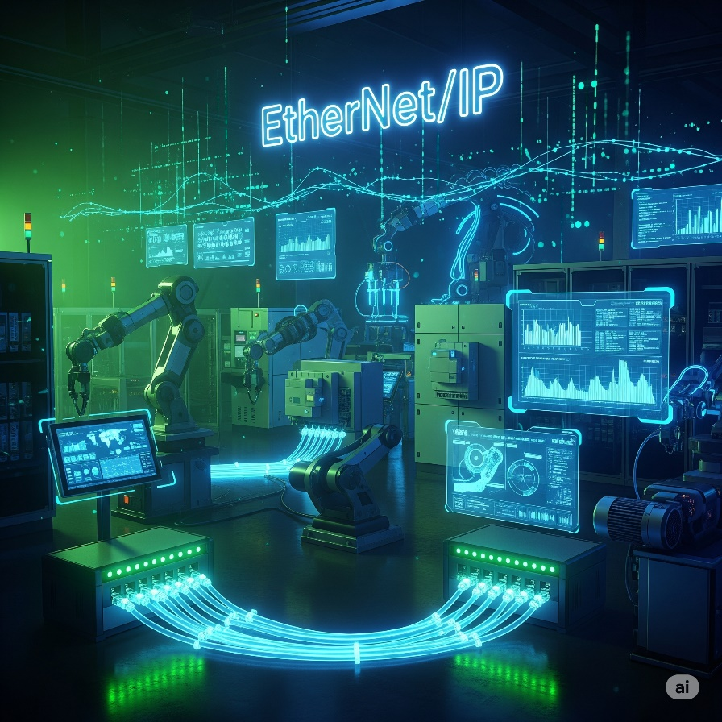

HOW TO CHOOSE YOUR CONTROLLER: THE "SMART BRAIN" CHECKLIST **🧠✅**

Choosing the right "brain" for your machine or system isn't just about grabbing the first thing off the shelf.

It's like picking the perfect teammate for a big project – you gotta consider a few key things to make sure they're a good fit!

This checklist is your cheat sheet to figure out what kind of programmable controller your project actually needs.

Step 1: New System or Existing System? 🏗️🔄

Are you building from scratch or adding to something already running?

**Why this matters:** It's like trying to connect a PlayStation 5 to an 80s TV - different tech doesn't always play nice together. Your new controller needs to communicate with existing equipment, or you'll have expensive paperweights.

**Pro-tip:** Check compatibility before buying to save headaches and money.

A factory tries to connect a new Allen-Bradley PLC to existing Siemens motor drives. The **Allen-Bradley** uses EtherNet/IP while the **Siemens** **drives** only speak Profibus - they literally can't communicate without **expensive gateway** converters, turning a simple upgrade into a costly nightmare.

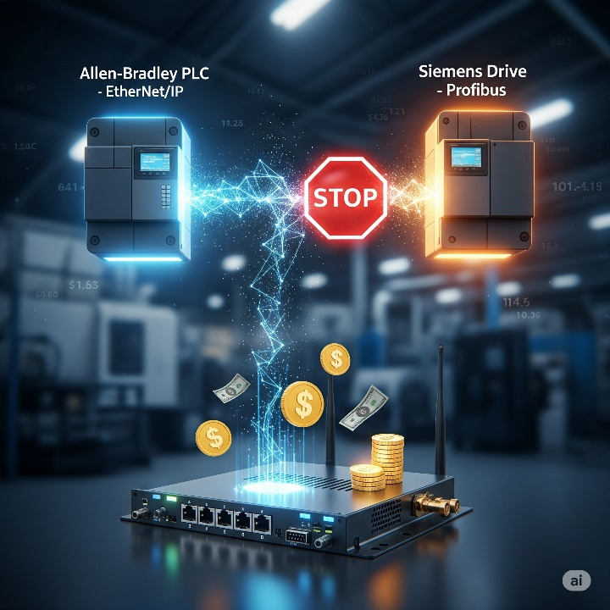

Step 2: Battle the Elements! (Environmental Check) **🌡️💨**

Where will your controller live? Nice air-conditioned office or hot, dusty factory floor? Consider things like:

* **Temperature:** Is it going to be super hot or freezing cold? 🔥❄️
* **Dust & Dirt:** Is the air full of grime, sawdust, or metallic particles? 🌬️
* **Vibration:** Is it going to be constantly shaking from heavy machinery nearby? ⚙️
* **Facility Codes:** Does your workplace have any special rules or safety codes about equipment (like needing to be explosion-proof)? 🚧
* **Why this matters(seriously!):** Imagine trying to use your smartphone in a sauna, or trying to take it deep-sea diving without a waterproof case. It's probably not gonna last long, right? 😬

Standard controllers work in 0-55°C (32-130°F), but extreme heat, dust, or constant shaking will kill them.

Choose ruggedized controllers for harsh environments or protect standard ones with proper enclosures. Skip this step and your whole operation stops when the controller dies.

